 | Managed Stack Explorer  Documentation
 |  |  |  |  | Last updated: 2/9/2006 7:54 PM
author |  | SaraF |  | Released date |  | 2/10/2006
Project Location |  | Managed Stack Explorer Homepage

1. Overview 2
1.1 Introduction 2
1.2 Product Information 2
2. Installation 3
2.1 System requirements 3
2.2 Install 3
2.3 Uninstall 3
3. Getting Started 3
3.1 Running Managed Stack Explorer 3
4. Using Managed Stack Explorer 3
4.1 GUI Overview 3
4.2 Getting information about a process 4
4.3 Viewing a process's threads 4
4.4 Viewing a stack trace 5
4.5 Saving a stack trace 5
4.6 Auto-refreshing the thread list 6
4.7 Auto-refreshing stack traces 6
4.8 Periodically logging stack traces 6
5. Command Line Usage 7
5.1 Usage 7
5.2 Viewing processes 7
5.3 Killing processes 8
5.4 Viewing process threads 8
5.5 Viewing thread stack trace 9
5.6 Viewing process stack trace 9
5.7 Logging to file 10
5.8 Viewing stack traces at a given interval 10
5.9 Viewing stack traces for a given duration 12
5.10 Viewing stack traces at a given interval for a given duration 13
5.11 Specifying stack trace depth 13
6. Known Issues 14
6.1 Running from network share 14
6.2 64-bit support 14
6.3 Running threads versus non-running threads 14
6.4 Older .NET Framework versions 15
7. Using the Sample App 15
8. Support 15
9. Change History 16

Overview

Introduction

Managed Stack Explorer (MSE) is a lightweight tool that provides a quick and easy way to monitor .NET 2.0 managed processes and their stacks. The ability to view a program’s stack and how it changes over time is an important method in determining reasons for possible errors. MSE provides a simple interface to allow you to monitor multiple processes at once and build periodic stack log files. MSE works by quickly attaching to a process when a stack trace is requested, then detaching the moment the stack trace has been retrieved. This way the interference in the normal operation of the process is minimized.

Both developers and their customers can use MSE to debug application hangs, especially when a debugging tool, like Visual Studio, is not available for use. The MSE logging feature allows for both developers and customers to include stack traces in bug reports and in troubleshooting scenarios.

Product Information

MSE is a member of the Power Toys for Visual Studio, developed by the Developer Solutions Team.

More information regarding MSE and other Power Toys can be found at the following locations:
- Managed Stack Explorer Homepage
- Developer Solutions and Power Toys Forums
- Developer Solutions Team Blog

Installation

System requirements

The following items are required for running the Managed Stack Explorer
- .NET Framework 2.0

Install

Included in the MSE.zip file
- MSE.exe
- Sample.exe
- Managed Stack Explorer Documentation.doc

There is no installer for MSE. Copy MSE.exe to wherever you want.

Uninstall

Simply delete all components listed in the above section. No other modifications are required.

Getting Started

Running Managed Stack Explorer

Managed Stack Explorer is both a command line tool as well as a graphical tool. Simply launch MSE.exe to use the graphical user interface. To use via the command line, just run mse.exe with command line arguments. See section 4 on Command Line Usage for more information.

Additionally, there’s a sample winform application included that allows you to try out MSE. See section 6 on Using the Sample App for more information.

Using Managed Stack Explorer

GUI Overview

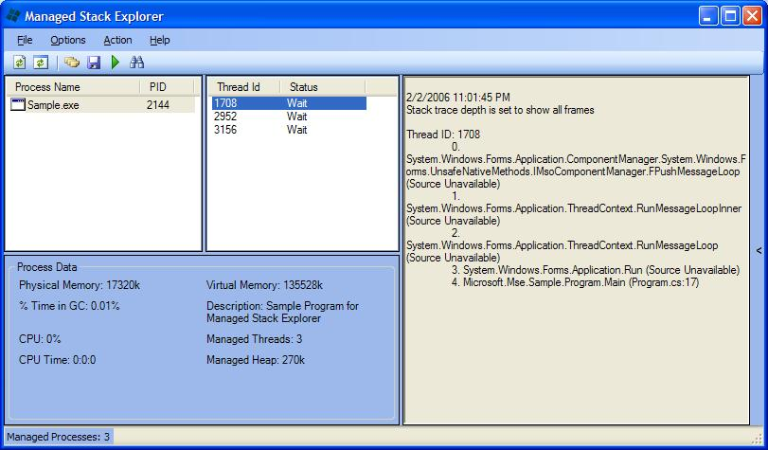

Getting information about a process

General information about any managed process is provided by just clicking on it in the process list. The group box below will populate with some useful information about the process. If you want to customize the data shown just right click on the group box and choose customize.

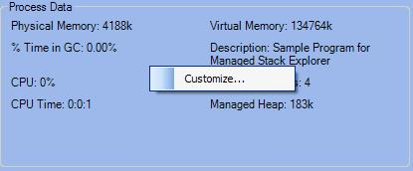

Viewing a process's threads

To view all the threads of a process, just double-click the process in the list.

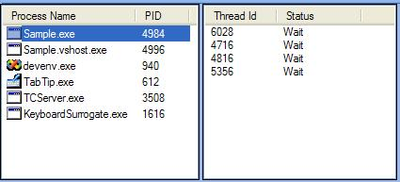

Viewing a stack trace

Once you have a list of the managed threads, you can view the stack trace of any or all of the threads. Select or control-select the threads you wish to view and press either the Enter key or the view stack trace toolbar button. The stack trace panel will expand to show you the requested stack trace(s).

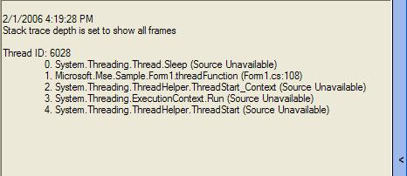

Saving a stack trace

When the stack pane is open, you can either press CTRL+S or the save toolbar button to save the stack trace to a file.

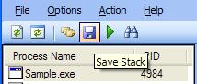

Auto-refreshing the thread list

In the toolbar there is an auto refresh thread list button. Clicking this button will cause the list of threads to automatically update periodically. This behavior isn't on by default, because update the thread list requires MSE to attach and detach from the process.

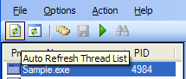

Auto-refreshing stack traces

In the toolbar there is an auto refresh stack trace button. Clicking this button will cause the currently viewed stack trace to automatically update periodically. This behavior isn't on by default because updating the stack trace requires MSE to attach and detach from the process.

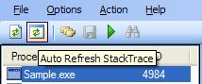

Periodically logging stack traces

This is one of the most important features of MSE. This allows you to build a log file over time of stack traces for specified processes and threads. To start stack logging, choose the threads of a process or processes you want to log the stacks of and press the log stack toolbar button. At this point, you will be prompted for a location to save your log file to. Logging stack traces will make the threads in the thread list and the process in the process list you are logging turn yellow. This will keep logging until you chose the process and press the stop log button.

You can also specify where to save log files at from the Save Stack toolbar button.

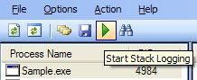

Command Line Usage

Usage

Use mse.exe /? for usage information.

Usage:
mse [process options] [thread options] [logging]
Process options:

/p(rocess) <process id,...> | Display list of managed processes
/i(nfo) | Display info about the specified process(es)
/k(ill) | Kill the process(es) specified by /p
/s(tack) | Display stack traces of all threads
/dep(th) <depth> | Number of stack frames to be shown when using /s. Default is to show all.

Thread options:

/t(hread) [<123>,<456>] | Display list of the threads of the process
/s(tack) | Display stack traces of specified thread(s)
/dep(th) <depth> | Number of stack frames to be shown when using /s. Default is to show all.

Logging options:

/o(ut) <filename> | Save output to a file
/l(og) | Display periodic stack traces.
/dur(ation) <seconds> | How long to display stack traces. Default is infinite.
/int(erval) <seconds> | How often to display updated stack traces. Default is 5 seconds

Example:
mse.exe /p 888 /t 2188 /l /int 5 /dur 30 /o log.txt

Viewing processes

Use mse.exe /p to display all managed processes currently running.

C:\Powertoys\MSE\StackExplorer\MSE>mse.exe /p
PID Process Name
4984 Sample.exe
4996 Sample.vshost.exe

Use mse.exe /p <process id> to display additional information regarding a managed process.

C:\Powertoys\MSE\StackExplorer\MSE>mse /p 4984
Process Info for Sample.exe [PID: 4984]
Description: Sample Program for Managed Stack Explorer
Company: Microsoft
CPU: 0%
CPU Time: 0:0:0
Physical Memory: 3216k
Virtual Memory: 136044k
Managed Threads: 4
Managed Heap: 183k
Gen 0 Collections: 2
Gen 1 Collections: 0
Gen 2 Collections: 0
% Time in GC: 0.00%

Killing processes

Use mse.exe /p <process id> /k to kill a managed process

C:\Powertoys\MSE\StackExplorer\MSE>mse.exe /p 4984 /k

Viewing process threads

Use mse.exe /p <process id> /t to view all running threads

C:\Powertoys\MSE\StackExplorer\MSE>mse.exe /p 4984 /t

Threads of Sample [PID: 4984]
Thread# 6028
Thread# 4716
Thread# 4816
Thread# 5356

Use mse.exe /p <process id> /t <thread id> /i to view information regarding a specific running thread

C:\Powertoys\MSE\StackExplorer\MSE>mse.exe /p 4984 /t 6028 /i
Process Info for Sample.exe [PID: 4984]
Description: Sample Program for Managed Stack Explorer
Company: Microsoft
CPU: 0%
CPU Time: 0:0:0
Physical Memory: 6000k
Virtual Memory: 135276k
Managed Threads: 4
Managed Heap: 183k
Gen 0 Collections: 3
Gen 1 Collections: 0
Gen 2 Collections: 0
% Time in GC: 0.00%

Viewing thread stack trace

Use mse.exe /p <process id> /t <thread id> /s to view a thread stack trace

C:\Powertoys\MSE\StackExplorer\MSE>mse.exe /p 4984 /t 6028 /s

Stack Trace for Sample.exe [PID: 4984]

2/1/2006 3:48:46 PM
Stack trace depth is set to show all frames

Thread ID: 6028
0. System.Threading.Thread.Sleep (Source Unavailable)
1. Microsoft.Mse.Sample.Form1.threadFunction (Form1.cs:108)
2. System.Threading.ThreadHelper.ThreadStart_Context (Source Unavailable
)
3. System.Threading.ExecutionContext.Run (Source Unavailable)
4. System.Threading.ThreadHelper.ThreadStart (Source Unavailable)

Viewing process stack trace

Use mse.exe /p <process id> /s to view stack traces for all running threads

C:\Powertoys\MSE\StackExplorer\MSE>mse.exe /p 4984 /s

Stack Trace for Sample.exe [PID: 4984]

2/1/2006 3:49:57 PM
Stack trace depth is set to show all frames

Thread ID: 6028
0. System.Threading.Thread.Sleep (Source Unavailable)
1. Microsoft.Mse.Sample.Form1.threadFunction (Form1.cs:108)
2. System.Threading.ThreadHelper.ThreadStart_Context (Source Unavailable
)
3. System.Threading.ExecutionContext.Run (Source Unavailable)
4. System.Threading.ThreadHelper.ThreadStart (Source Unavailable)

Thread ID: 4716

Thread ID: 4816
0. System.Windows.Forms.Application.ComponentManager.System.Windows.Form
s.UnsafeNativeMethods.IMsoComponentManager.FPushMessageLoop (Source Unavailable)

1. System.Windows.Forms.Application.ThreadContext.RunMessageLoopInner (S
ource Unavailable)
2. System.Windows.Forms.Application.ThreadContext.RunMessageLoop (Source
Unavailable)
3. System.Windows.Forms.Application.Run (Source Unavailable)
4. Microsoft.Mse.Sample.Program.Main (Program.cs:17)

Thread ID: 5356
0. System.Threading.Thread.Sleep (Source Unavailable)
1. Microsoft.Mse.Sample.Form1.threadFunction (Form1.cs:108)
2. System.Threading.ThreadHelper.ThreadStart_Context (Source Unavailable
)
3. System.Threading.ExecutionContext.Run (Source Unavailable)
4. System.Threading.ThreadHelper.ThreadStart (Source Unavailable)

Logging to file

Use the /o <filename> parameter at any time to log information to a file instead of the console.

C:\Powertoys\MSE\StackExplorer\MSE>mse.exe /p 4984 /t 6028 /o log.txt
C:\Powertoys\MSE\StackExplorer\MSE>more log.txt

Stack Trace for Sample.exe [PID: 4984]

2/1/2006 3:48:46 PM
Stack trace depth is set to show all frames

Thread ID: 6028
0. System.Threading.Thread.Sleep (Source Unavailable)
1. Microsoft.Mse.Sample.Form1.threadFunction (Form1.cs:108)
2. System.Threading.ThreadHelper.ThreadStart_Context (Source Unavailable
)
3. System.Threading.ExecutionContext.Run (Source Unavailable)
4. System.Threading.ThreadHelper.ThreadStart (Source Unavailable)

Viewing stack traces at a given interval

Use mse.exe /p <process id> /t <thread id> /l to view a thread stack trace every 5 seconds

C:\Powertoys\MSE\StackExplorer\MSE>mse.exe /p 4984 /t 6028 /l
Logging every 5 seconds

Stack Trace for Sample.exe [PID: 4984]

2/1/2006 3:51:30 PM
Stack trace depth is set to show all frames

Thread ID: 6028
0. System.Threading.Thread.Sleep (Source Unavailable)
1. Microsoft.Mse.Sample.Form1.threadFunction (Form1.cs:108)
2. System.Threading.ThreadHelper.ThreadStart_Context (Source Unavailable
)
3. System.Threading.ExecutionContext.Run (Source Unavailable)
4. System.Threading.ThreadHelper.ThreadStart (Source Unavailable)

Stack Trace for Sample.exe [PID: 4984]

2/1/2006 3:51:35 PM
Stack trace depth is set to show all frames

Thread ID: 6028
0. System.Threading.Thread.Sleep (Source Unavailable)
1. Microsoft.Mse.Sample.Form1.threadFunction (Form1.cs:108)
2. System.Threading.ThreadHelper.ThreadStart_Context (Source Unavailable
)
3. System.Threading.ExecutionContext.Run (Source Unavailable)
4. System.Threading.ThreadHelper.ThreadStart (Source Unavailable)

Use mse.exe /p <process id> /t <thread id> /l <seconds> to view a thread stack trace at the given interval

C:\Powertoys\MSE\StackExplorer\MSE>mse.exe /p 4984 /t 6028 /l /int 10
Logging every 10 seconds

Stack Trace for Sample.exe [PID: 4984]

2/1/2006 3:52:12 PM
Stack trace depth is set to show all frames

Thread ID: 6028
0. System.Threading.Thread.Sleep (Source Unavailable)
1. Microsoft.Mse.Sample.Form1.threadFunction (Form1.cs:108)
2. System.Threading.ThreadHelper.ThreadStart_Context (Source Unavailable
)
3. System.Threading.ExecutionContext.Run (Source Unavailable)
4. System.Threading.ThreadHelper.ThreadStart (Source Unavailable)

Stack Trace for Sample.exe [PID: 4984]

2/1/2006 3:52:22 PM
Stack trace depth is set to show all frames

Thread ID: 6028
0. System.Threading.Thread.Sleep (Source Unavailable)
1. Microsoft.Mse.Sample.Form1.threadFunction (Form1.cs:108)
2. System.Threading.ThreadHelper.ThreadStart_Context (Source Unavailable
)
3. System.Threading.ExecutionContext.Run (Source Unavailable)
4. System.Threading.ThreadHelper.ThreadStart (Source Unavailable)

Viewing stack traces for a given duration

Use mse.exe /p <process id> /t <thread id> /l /dur <seconds> to display thread stack trace every 5 seconds for the given duration

C:\Powertoys\MSE\StackExplorer\MSE>mse.exe /p 4984 /t 6028 /l /dur 10
Logging every 5 seconds for 10 seconds

Stack Trace for Sample.exe [PID: 4984]

2/1/2006 3:53:05 PM
Stack trace depth is set to show all frames

Thread ID: 6028
0. System.Threading.Thread.Sleep (Source Unavailable)
1. Microsoft.Mse.Sample.Form1.threadFunction (Form1.cs:108)
2. System.Threading.ThreadHelper.ThreadStart_Context (Source Unavailable
)
3. System.Threading.ExecutionContext.Run (Source Unavailable)
4. System.Threading.ThreadHelper.ThreadStart (Source Unavailable)

Stack Trace for Sample.exe [PID: 4984]

2/1/2006 3:53:10 PM
Stack trace depth is set to show all frames

Thread ID: 6028
0. System.Threading.Thread.Sleep (Source Unavailable)
1. Microsoft.Mse.Sample.Form1.threadFunction (Form1.cs:108)
2. System.Threading.ThreadHelper.ThreadStart_Context (Source Unavailable
)
3. System.Threading.ExecutionContext.Run (Source Unavailable)
4. System.Threading.ThreadHelper.ThreadStart (Source Unavailable)

Viewing stack traces at a given interval for a given duration

Use mse.exe /p <process id> /t <thread id> /l /int <seconds> /dur <seconds> to view a thread stack trace at a given interval for a given duration.

C:\Powertoys\MSE\StackExplorer\MSE>mse.exe /p 4984 /t 6028 /l /int 10
/dur 20
Logging every 10 seconds for 20 seconds

Stack Trace for Sample.exe [PID: 4984]

2/1/2006 3:53:57 PM
Stack trace depth is set to show all frames

Thread ID: 6028
0. System.Threading.Thread.Sleep (Source Unavailable)
1. Microsoft.Mse.Sample.Form1.threadFunction (Form1.cs:108)
2. System.Threading.ThreadHelper.ThreadStart_Context (Source Unavailable
)
3. System.Threading.ExecutionContext.Run (Source Unavailable)
4. System.Threading.ThreadHelper.ThreadStart (Source Unavailable)

Stack Trace for Sample.exe [PID: 4984]

2/1/2006 3:54:07 PM
Stack trace depth is set to show all frames

Thread ID: 6028
0. System.Threading.Thread.Sleep (Source Unavailable)
1. Microsoft.Mse.Sample.Form1.threadFunction (Form1.cs:108)
2. System.Threading.ThreadHelper.ThreadStart_Context (Source Unavailable
)
3. System.Threading.ExecutionContext.Run (Source Unavailable)
4. System.Threading.ThreadHelper.ThreadStart (Source Unavailable)

Specifying stack trace depth

Use mse.exe /p <process id> /t <thread id> /l /dep <depth> to specify how many frames to show in the call stack.

C:\Powertoys\MSE\StackExplorer\MSE>mse.exe /p 4984 /t 6028 /l /dep 2
Logging every 5 seconds

Stack Trace for Sample.exe [PID: 4984]

2/1/2006 3:55:15 PM
Stack trace depth is 2 frames
n
Thread ID: 6028
0. System.Threading.Thread.Sleep (Source Unavailable)
1. Microsoft.Mse.Sample.Form1.threadFunction (Form1.cs:108)

Known Issues

Running from network share

MSE requires "FullTrust" permission to run. By default, when a managed application is run from a network share, it gets "Intranet" permission which is less than what we require for MSE. For making MSE work from a network share, .Net security policy needs to be updated to grant "FullTrust" permission to MSE. Either the GUI tool mscorcfg.msc or the following command (requires caspol.exe be in the path) can be used to modify the .Net security policy.
caspol.exe -machine -addgroup 1. -strong -file <PATH_TO_MSE> -noname -noversion FullTrust -name "Managed Stack Explorer" -description "Code group for Managed Stack Explorer"

64-bit support

On 64-bit machines, MSE can only monitor 64-bit or 32-bit, but not both at the same time. The default configuration is to run MSE as a 64-bit process to monitor other 64-bit applications.

Older .NET Framework versions

MSE is a .NET 2.0 program and therefore can only get the stack trace of other .NET 2.0 programs.

Using the Sample App

Included with the installation is a winform app called Sample.exe that allows for testing against MSE. The Sample Program for Managed Stack Explorer allows you to add and remove threads, which you can actively monitor in MSE.

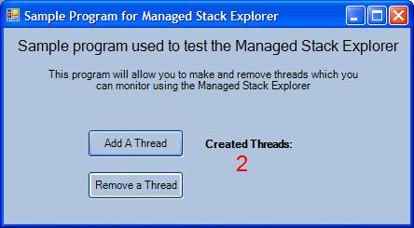

Support

For general questions, including “How Do I…”, visit the Developer After-market Solutions and Power Toys Forums.

Bug reports and suggestions can be filed on the Managed Stack Explorer bug reporting site.

For general questions related to Power Toys for Visual Studio, visit the Developer Solutions Team blog.

Change History

Change | Changed By | Date
Created | SaraF@microsoft.com | 1/31/2006
Updated with review feedback | SaraF@microsoft.com | 2/8/2006

